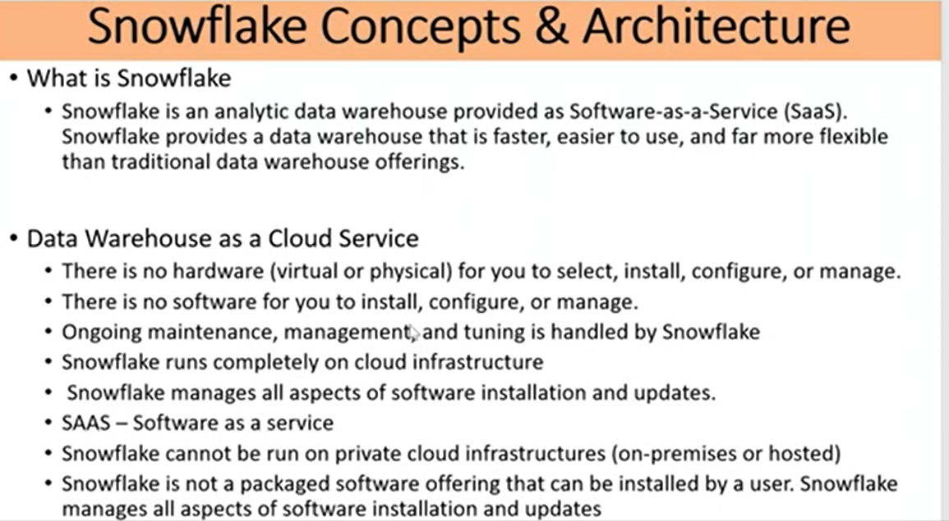

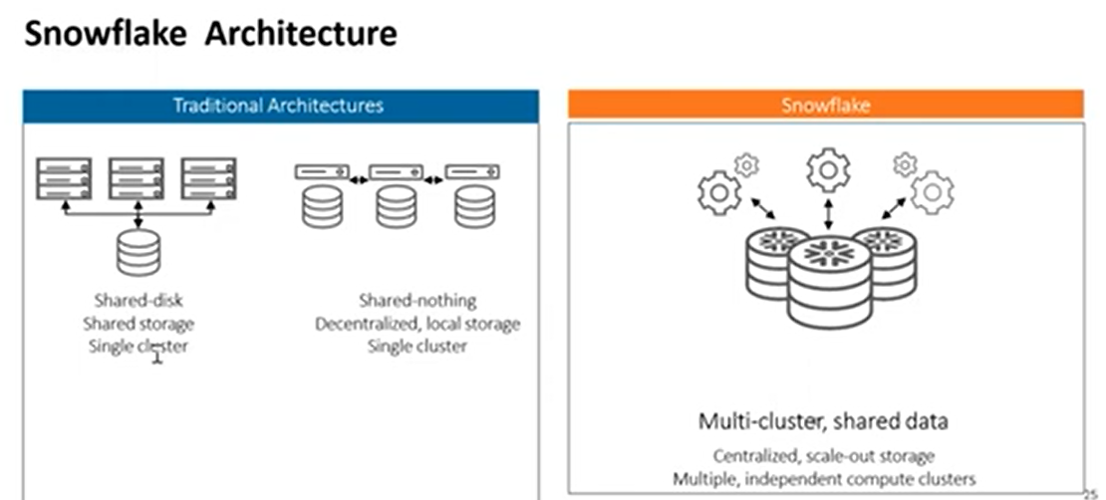

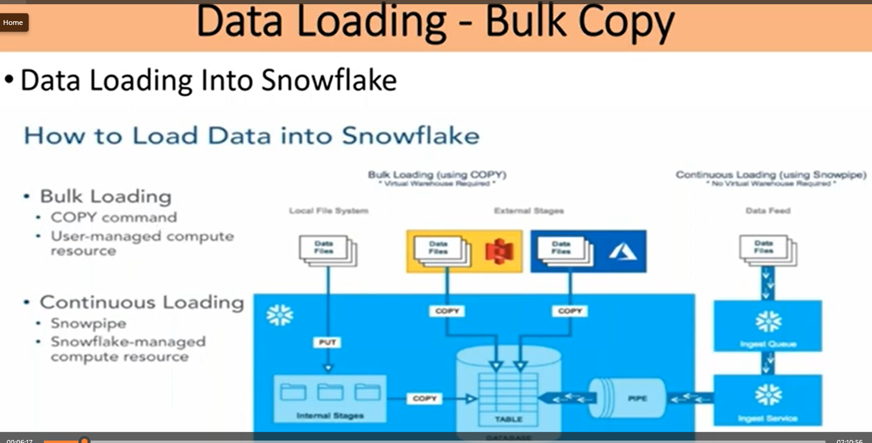

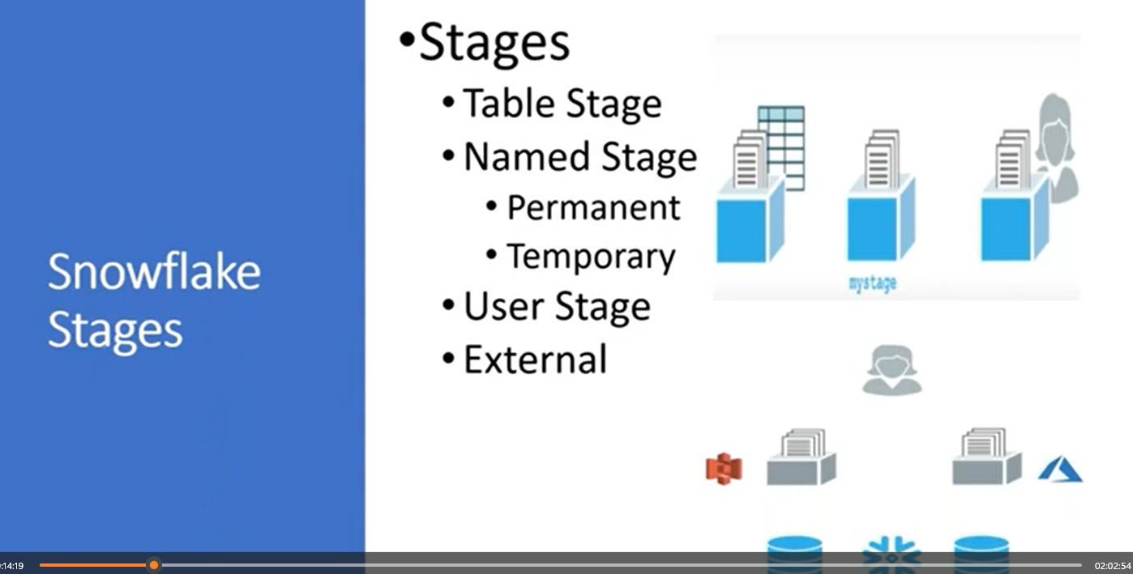

Again upload the new file in bucket

